| Name: Abdul Hadi Qureshi | EE-272L Digital Systems Design |
| --- | --- |
| Reg. No.: 2023-EE-015 | Marks Obtained: ____________ |



**Lab Manual**

| **DSD Lab Manual Evaluation Rubrics** | | | | | |
| --- | --- | --- | --- | --- | --- |
|  |  |  |  |  |  |
| **Assessment** | **Total Marks** | **Marks Obtained** | **0-30%** | **30-60%** | **70-100%** |
| Code Organization (CLO1) | 3 |  | No Proper Indentation and descriptive naming, no code organization.  Zero to Some understanding but not working | Proper Indentation or descriptive naming or code organization.  Mild to Complete understanding but not working | Proper Indentation and descriptive naming, code organization.  Complete understanding, and proper working |
| Simulation (CLO2) | 5 |  | Simulation not done or incorrect, without any understanding of waveforms | Working simulation with errors, don't cares's(x) and high impedance(z), partial understanding of waveforms | Working simulation without any errors, etc and complete understanding of waveforms |
| FPGA (CLO2) | 2 |  | Not implemented on FPGA and questions related to synthesis and implementation not answered. | Correctly Implemented on FPGA or questions related to synthesis and implementation answered. | Correctly Implemented on FPGA and questions related to synthesis and implementation answered. |

**Experiment 1: MOSFET as an Inverter**

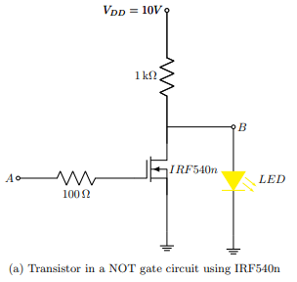

**PART A:**

**Q1) At 5V:**

$V{}_{T}$ = 0V

The LED does NOT glow,

When 5V is applied at terminal A, the mosfet acts as a short circuit (Mosfet turns ON), the drain and source is shorted to the ground, therefore the voltage at terminal B is also grounded, all the voltage gets grounded, so the voltage across the LED is 0V and no current passes through the LED, which resulted the LED in not glowing.

**Q2)At 0V:**

$V{}_{T}$ = 1.9V

The LED glows,

When 0V is applied at terminal A, the mosfet acts as a open circuit (Mosfet turns OFF), this time the source and drain does not get connected to the ground, meaning that no current flows across the mosfet, there is a voltage generated across the LED, current passes through the LED which resulted the LED in glowing.

**Q3)** **Propagation delay at 1 kHz, 5V peak voltage (from low voltage to high voltage):** 2.8 $μs$

**Q4)** **Propagation delay at 100 kHz, 5V peak voltage (from low voltage to high voltage):**

2.4 $μs$

**Q5) Effect of frequency on operation of a transistor:**

At low frequencies the mosfet behaves as a capacitor, or we can say that the capacitive effect is very high, due to which the propagation delay is greater at low frequencies.

At high frequencies the capacitive effect is negligible which also leads to a lesser propagation delay.

**PART B:**

**At 1KHz:**

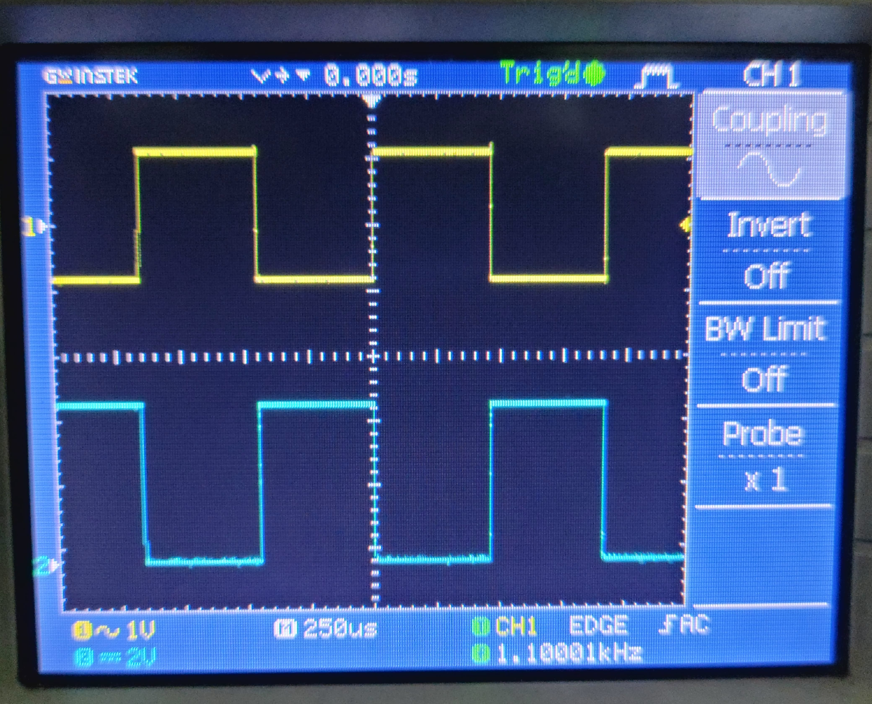

Fig 1

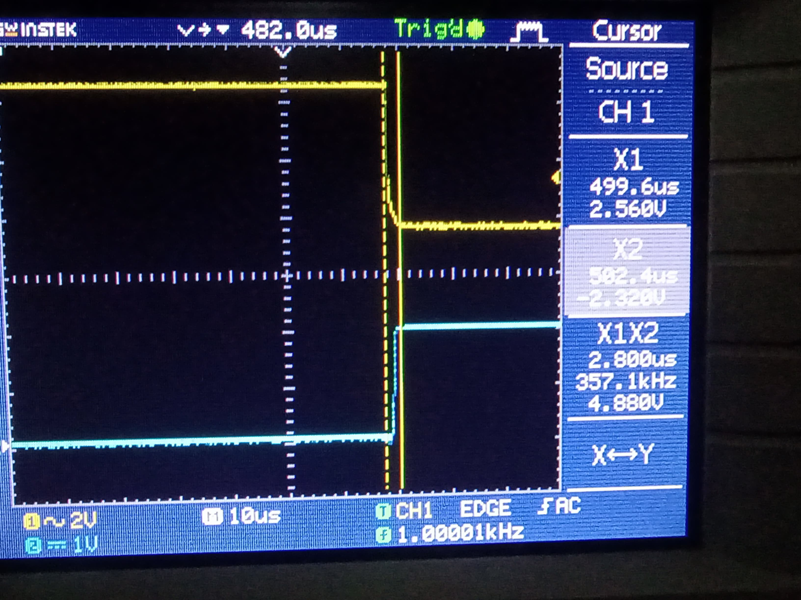

Fig 2

**At 100KHz:**

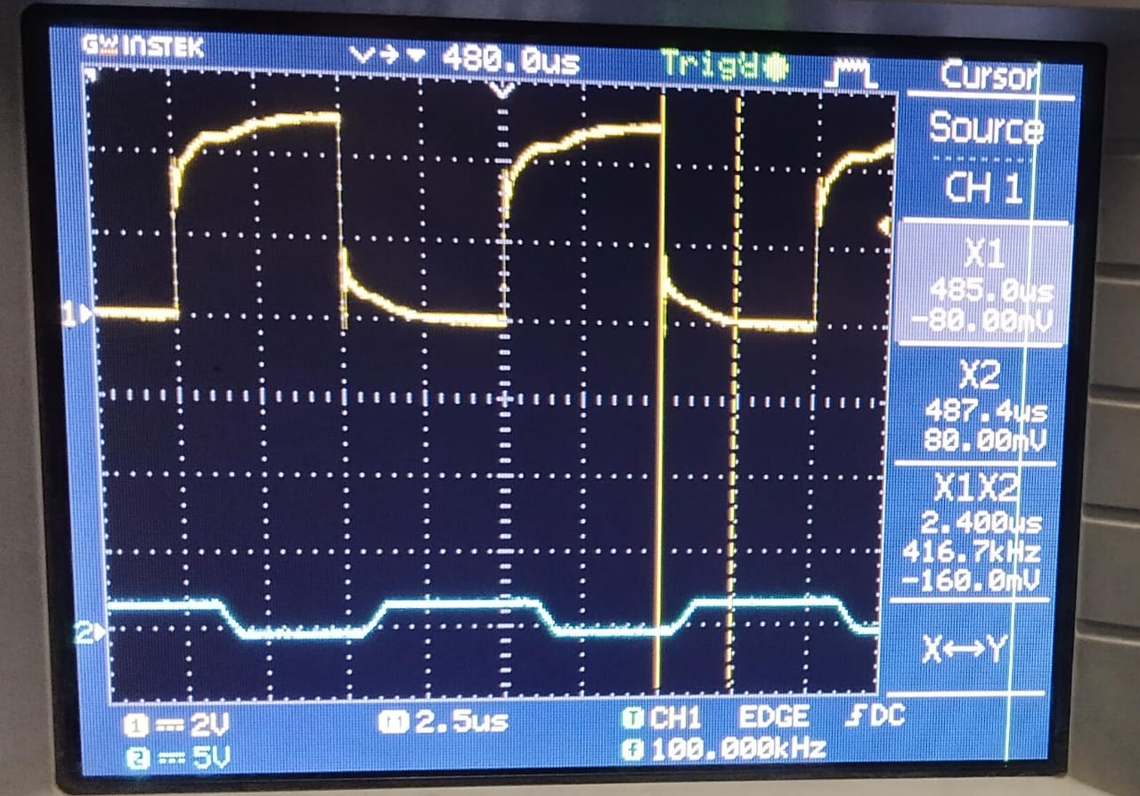

Fig 3